Lauren Burns
Olympic Gold Medallist, Taekwondo Sydney 2000

Lauren Burns created sporting history by winning the first Olympic gold medal for Taekwondo when the sport made its debut at the Sydney 2000 Olympic Games. Lauren was one of only three Australian women to win an individual Olympic Gold Medal, along with Cathy Freeman and Susie O’Neill. Her amazing triumph at the Sydney Games was achieved against the odds – requiring enormous discipline, commitment, perseverance and teamwork.

The nation watched as Lauren’s victory brought the Australian public and Olympic crowd to its feet. Before her Olympic win, few people knew that Lauren had been 12 times Australian Champion and had achieved a string of international titles including numerous medals at world championship level. Lauren’s gold medal has put Australia on the map as a major international competitor for the sport of Taekwondo.

Since the Sydney Olympics, Lauren has emerged as one of the most successful Olympians from these Games. She is one of Australia’s most sought after speakers and has spoken to over 200,000 people since these Games. Ten years on, Lauren continues to travel the country conducting presentations, workshops and corporate health programs.

Lauren enjoys a variety of commitments; she is the mother of 2 beautiful children, she is involved with Red Dust Role Models, conducting healthy lifestyle clinics in remote Aboriginal, Fijian & Indian communities. She is a director on the board of her parents charity Appin Hall Children’s Foundation and practices as a naturopath in Northcote.

The success of Lauren’s autobiography, Fighting Spirit resulted in her travelling Australia to promote the book, which was listed in the Sydney Morning Herald as the number one best selling sports book. She has recently released her latest book Food from a Loving Home, a collection of vegetarian recipes. This book is a sharing of Lauren’s favourite recipes, her knowledge about creating tasty wholesome and exciting meals along with home remedies and kitchen cupboard cures using ingredients found in any kitchen.

To book Lauren to speak at your event, please contact Parliament on:
+44(0)1202 24 24 24

Lauren’s own design of the Zip Bag, under the umbrella company Love Your Planet.

The idea was born from a handy fold out bag she found in an op shop, reminding her of one her Nana owned. With the rapid rise in plastic bag use, she thought it was a perfect time to reinvent this little gem.

The success of the green bag clearly demonstrates changing attitudes but certainly isn’t first choice for the catwalk! The zip bag is stylish and fashionable along with being highly practical. The pattern provides a beauty of nature combined with the symbol of the heart pattern representing love, happiness and creating a harmonious world. It is a must for every handbag.

http://www.loveyourplanet.com.au

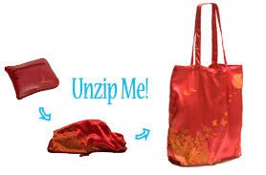

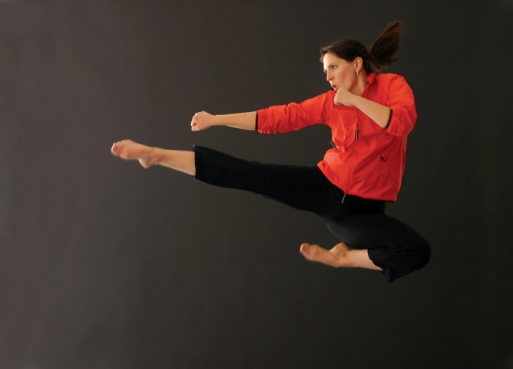

CAREER RESULTS

National competition experience

12 times National Champion
- Australian team member 1993 - 2000

International highlights
- 2000 Olympic Gold Medallist
- 2000 US Open – Silver
- 1999 US Open – Gold
- 1997 World Championships, Bronze
- 1996 World Cup, Bronze
- 1995 Belgian Open, Gold
- 1994 IOC Seoul Invitational – Gold

ACHIEVEMENTS

- Bachelor Health Science (Naturopathy, Nutrition, Herbal Medicine)
- Australian Natural Therapists Association – Bursary Award 2009
- Best selling author Fighting Spirit
- Order of Australia Medal
- 3rd Dan black belt
- Young Australian of the Year, Nillumbik Shire, 2001
- Sports Medal Recipient, 2001
- Leader Newspaper Sports Star of the year, 1999
- Blitz Female Full Contact Fighter of the Year, 1999, 2001
- Women’s Team Captain, Australian Taekwondo Team
- Taekwondo Australia Fighter of the Year, 2000

ASSOCIATIONS
- Red Dust Role Models
- Appin Hall Children’s Foundation
- Ambassador for World Vision’s Destroy a Minefield campaign in Cambodia (2001 – 2002)
- Athletes Commission of both the Australian Olympic Committee and Taekwondo Australia
- Commentator the Athens and Beijing Olympic Games, taekwondo

"I just felt tonight that all my competitors were tough, they were the best in the world and I had to go out and give it everything I had… I had to give it heart, give it soul, give it passion and the Australian crowd really helped to lift me up… The energy was incredible."
Lauren Burns, 2000

For more information:
http://www.laurenburns.com
laurenburns@ozemail.com.au

